**SMART SOLUTION FOR RAILWAYS**

**SUBMITTED BY**

**SWETHA .G (113219041121)**

**MEENA.C (113219041066)**

**RASIKA.J (113219041094)**

**MALAVIKA.R (113219041062)**

# BACHELOR OF ENGINEERING ELECTRONICS AND COMMUNICATION ENGINEERING

**BLOCK DIAGRAM :**

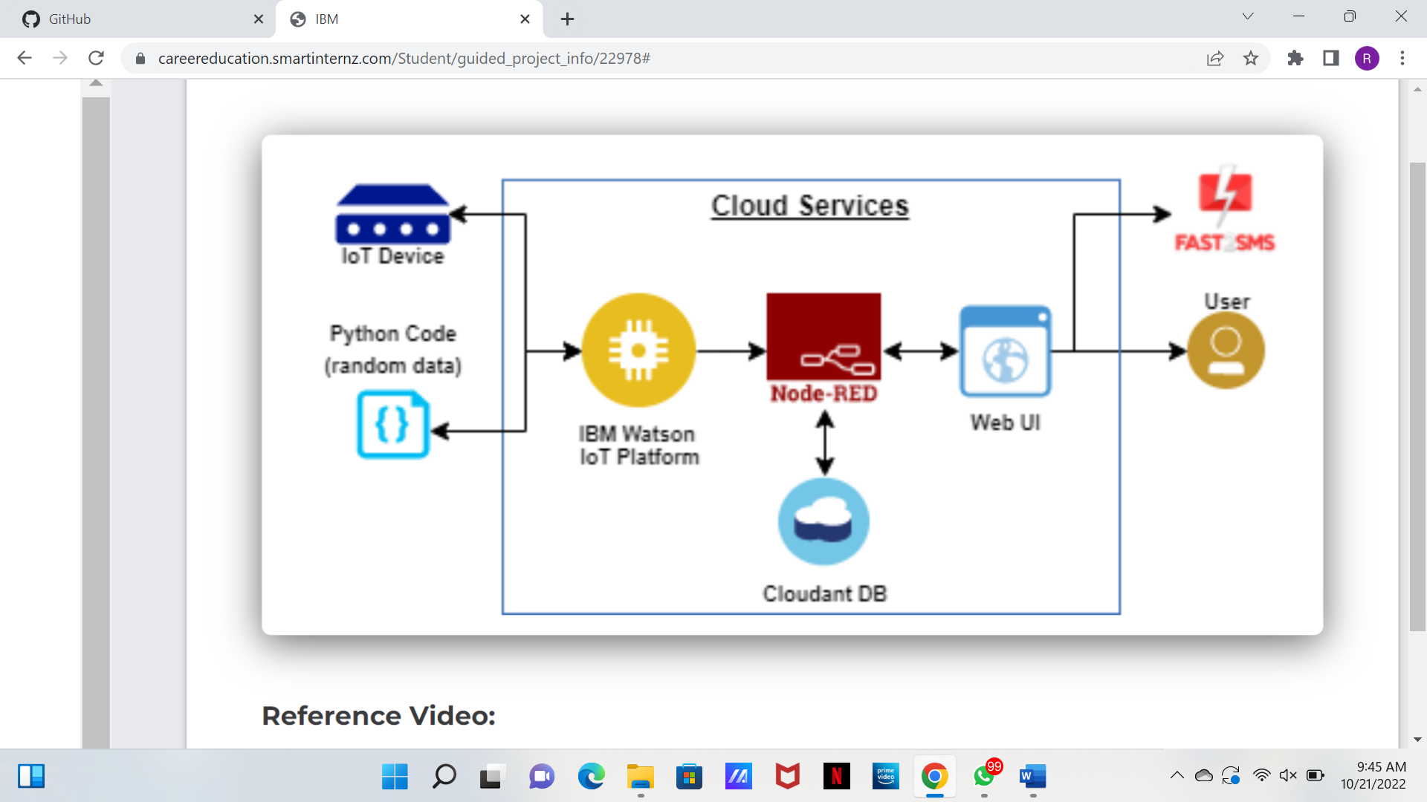

**ARCHITECTURE :**

* A Web page is designed for the public where they can book tickets by seeing the available seats.
* After booking the train, the person will get a QR code which has to be shown to the Ticket Collector while boarding the train.
* The ticket collectors can scan the QR code to identify the personal details.
* A GPS module is present in the train to track it. The live status of the journey is updated in the Web app continuously
* All the booking details of the customers will be stored in the database with a unique ID and they can be retrieved back when the Ticket Collector scans the QR Code.